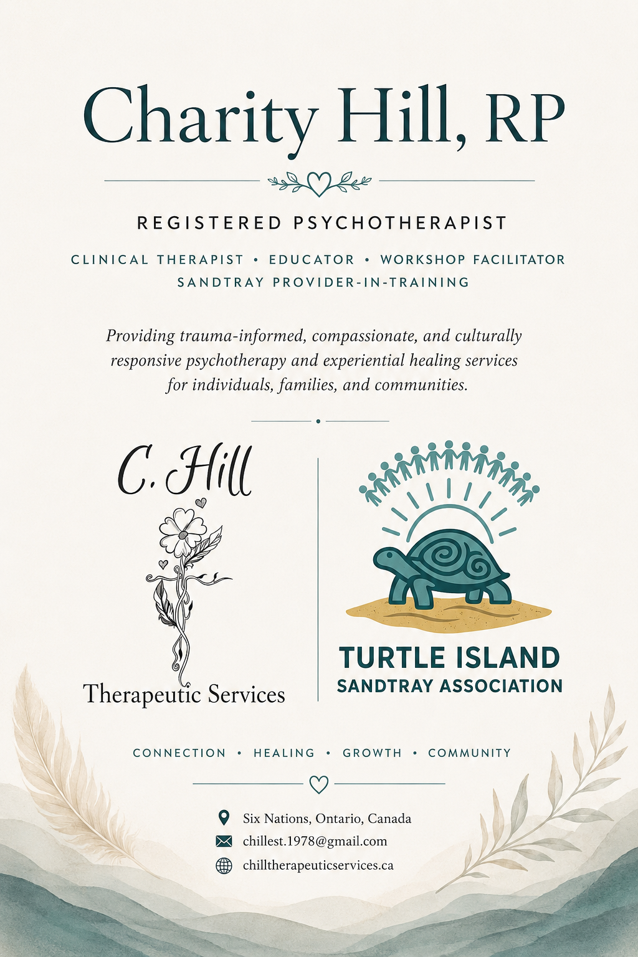

Table of Contents
- Professional Header .............................................................. 3
- Professional Summary .......................................................... 4
- Education ............................................................................. 5
- Professional Registration & Memberships .............................. 6
- Clinical Positions & Professional Experience .......................... 7
  - Owner & Registered Psychotherapist — C. Hill Therapeutic Services
  - Founder & Clinical Educator — Turtle Island Sandtray Association
  - Family Services Worker — Ogwadeni:deo
  - Therapeutic Support Worker / Group Facilitator — Katawasin Counselling Agency
  - Cultural Coordinator — Six Nations Tourism
  - 0–6 Intensive Worker — Six Nations Child & Family Services
  - Primary Prevention Worker — Six Nations Child & Family Services
  - Addictions Outreach Worker — Six Nations Health Services
- Certifications & Specialized Training ................................... 11
  - Sandtray Therapy & Expressive Therapies
  - Provider-in-Training Facilitation — Caribbean Sandtray Institute
  - Trauma, Attachment & Neurodevelopment
  - Narrative & Relational Therapies
  - Sexuality & Human Development
  - Professional Development & Creative Healing
- Therapeutic Modalities ...................................................... 12
- Prior to 2020 Professional Training & Certifications …………..13
- Leadership & Community Involvement ............................... 15
- References ....................................................................... 16
Available Upon Request
Charity Hill, RP
Registered Psychotherapist
Clinical Educator • Workshop Facilitator • Sandtray Provider-in-Training
Founder, C. Hill Therapeutic Services
Founder, Turtle Island Sandtray Association
📍 Six Nations, Ontario, Canada
📧 chillest.1978@gmail.com
🌐 chilltherapeuticservices.ca
Trauma-Informed • Sandtray Therapy • Indigenous-Informed Healing

Professional Summary

Charity Hill, RP, is a Registered Psychotherapist, clinical educator, and founder of C. Hill Therapeutic Services and Turtle Island Sandtray Association. She provides trauma-informed, client-centred psychotherapy services for children, youth, adults, couples, and families through in-person, virtual, and telephone-based care. Her work integrates Sandtray Therapy, experiential approaches, symbolic healing practices, and developmentally responsive interventions to support emotional regulation, self-awareness, connection, and healing.
Charity is passionate about creating therapeutic and educational spaces grounded in relationship, cultural humility, spirituality, and holistic wellness. Her professional interests include trauma recovery, neurodevelopment, interpersonal neurobiology, Indigenous-informed healing approaches, expressive therapies, and clinical training development. In addition to her clinical work, she develops and facilitates experiential workshops, team-building programs, and Sandtray Therapy training curriculum focused on connection, reflection, and meaningful therapeutic practice.

Education

Master of Arts in Counselling Psychology
Yorkville University
2020 - 2023
Bachelor of Arts (Honours) in Youth & Child Studies
Minors in Psychology and Indigenous Studies
Wilfrid Laurier University
2014 – 2020
Infant Mental Health Studies
York University
2011 – 2012
Native University Access Program
Six Nations Polytechnic
2011 – 2012
Native Community Care Diploma
Mental Health & Addictions Stream — Graduated with High Honours
Mohawk College
1998 – 2000

Professional Registration & Memberships

- Registered Psychotherapist (RP) — College of Registered Psychotherapists of Ontario (CRPO)
Member #11624 | Active Registration: April 6, 2022 – February 13, 2027
- Canadian Certified Counsellor (CCC) — Canadian Counselling and Psychotherapy Association (CCPA)
Member #11241440 | Active Certification: January 6, 2025 – December 1, 2028
- Internationally Credentialed Sandtray Therapist (ICST) — International Association for Sandtray Therapy (IAST)
Credentialed Member #11624 | Active: September 24, 2023 – August 1, 2026
- ICST-P — Internationally Credentialed Sandtray Therapist, Provider-in-Training
International Association for Sandtray Therapy (IAST)
- Founder & Registered Psychotherapist — C. Hill Therapeutic Services
- Founder & Clinical Educator — Turtle Island Sandtray Association

Clinical Positions & Professional Experience
Owner & Registered Psychotherapist
C. Hill Therapeutic Services
Ontario, Canada | April 2024 – Present
- Provide psychotherapy services for individuals, couples, youth, children, and families through in-person, virtual, and telephone-based care
- Utilize Sandtray Therapy, trauma-informed interventions, attachment-based approaches, and experiential therapeutic modalities
- Support clients experiencing trauma, grief, anxiety, emotional dysregulation, relational difficulties, and life transitions
- Facilitate therapeutic workshops, psychoeducational programming, and experiential healing groups
- Integrate Indigenous-informed, culturally responsive, and land-based perspectives into therapeutic practice
- Conduct clinical assessments, treatment planning, case management, and ongoing therapeutic support
- Develop therapeutic resources, wellness initiatives, and community-based healing programs

Founder & Clinical Educator
Turtle Island Sandtray Association
Ontario, Canada | 2025 – Present
- Develop Levels 1–4 Sandtray Therapy curriculum for clinicians and helping professionals
- Facilitate experiential Sandtray Therapy workshops, team-building programs, and professional development training
- Provide consultation, mentorship, and educational support for therapists integrating Sandtray Therapy into clinical practice
- Integrate neuroscience, interpersonal neurobiology, spirituality, symbolism, and expressive healing approaches into curriculum development
- Design culturally respectful and Indigenous-informed educational materials grounded in connection, reflection, and experiential learning
- Create training manuals, presentations, experiential activities, and continuing education resources for professional audiences

Family Services Worker
Ogwadeni:deo
February 2021 – November 2021
- Worked in adherence with provincial child welfare standards, guidelines, and the Child, Youth and Family Services Act (CYFSA)
- Managed family service files, assessed family needs, completed referrals, and supported family reunification planning
- Collaborated with Band Representatives and interdisciplinary teams regarding case planning and service coordination
- Prepared temporary care agreements and formal customary care agreements
- Participated in collaborative planning and case management to support child and family wellbeing

Therapeutic Support Worker / Group Facilitator
Katawasin Counselling Agency
September 2018 – February 2021
- Co-facilitated Healing Hearts grief therapy groups for children and adults
- Assisted with therapeutic planning and consultation for client care
- Supported clients through holistic and relationship-based healing approaches
- Participated in mentorship and ongoing professional development related to experiential and holistic therapeutic techniques

Cultural Coordinator
Six Nations Tourism
July 2017 – August 2018
- Developed and implemented Indigenous-focused educational curriculum for visitors of all ages at Her Majesty’s Royal Chapel of the Mohawks
- Facilitated historical and cultural tours highlighting Six Nations history, culture, and contributions to Canadian history
- Managed tourism initiatives, promotions, daily operations, and community engagement activities
- Hired, trained, and supervised contract staff and volunteers
- Collaborated with the Chapel Committee Board of Directors regarding operations and strategic planning
- Assisted with budget oversight, grant proposals, funding requests, and employment incentive applications

0–6 Intensive Worker — Clinical Services Unit
Six Nations Child & Family Services
October 2010 – July 2017
- Provided therapeutic and developmental support services for children ages 0–6 and their families
- Developed therapeutic plans of care within home, school, and community environments
- Participated in planning, facilitation, and consultation for therapeutic and psychoeducational groups
- Conducted ongoing reassessment of client and group needs and adjusted service plans accordingly
- Coordinated referrals and collaborated with community organizations and interdisciplinary teams
- Assisted with annual work plans, program development, and budget planning
- Developed and facilitated therapeutic behaviour plans in collaboration with caregivers and community supports

Primary Prevention Worker
Six Nations Child & Family Services
July 2007 – October 2010
- Assisted in the planning and development of primary prevention and wellness promotion programming
- Participated in collaborative problem-solving, work planning, and team meetings
- Organized and facilitated after-school, school-based, and summer programming for children, youth, and families
- Delivered workshops, seminars, prevention initiatives, and community wellness events
- Supported family-focused prevention programming and community engagement initiatives

Addictions Outreach Worker
Six Nations Health Services
June 2000 – June 2007
- Assisted in the development, implementation, and evaluation of community outreach activities and wellness initiatives
- Utilized a collaborative team approach to provide support services for clients, families, and community members
- Participated in the development of addiction and wellness programming in response to community needs
- Coordinated youth-focused programs, drop-in initiatives, and community-based activities
- Provided mentorship and leadership support to co-workers and program participants

Certifications & Specialized Training

Sandtray Therapy & Expressive Therapies
- Level 1: Introduction to Sandtray Play Therapy — Canadian Sandtray Institute (2023)
- Level 2: The Neuroscience of Sandtray Play Therapy — Canadian Sandtray Institute (2023)
- Level 3: Advanced Case Consultation and Personal Work in Sandtray Play Therapy — Canadian Sandtray Institute (2024)
- Level 4: Advanced Sandtray Therapy Course on Trauma — Canadian Sandtray Institute (2024)
- 7th Annual IAST Sandtray Summit — International Association for Sandtray Therapy (2025)
- 8th Annual IAST Sandtray Summit — International Association for Sandtray Therapy (2026)
- Walking With My Shadow — International Association for Sandtray Therapy (2025)
Provider-in-Training Facilitation — Caribbean Sandtray Institute
- Levels 1–4 Sandtray Play Therapy Training (Provider-in-Training Role) — Caribbean Sandtray Institute (2026)
Trauma, Attachment & Neurodevelopment
- Dyadic Developmental Psychotherapy (DDP) Level 1 Training — Dyadic Developmental Psychotherapy Institute (2023)
- BrainWorking Recursive Therapy (BWRT) Level 1 (2023)
Narrative & Relational Therapies
- Narrative Therapy Online Foundations — Vancouver School for Narrative Therapy (2025)
Sexuality & Human Development
- Sexual Attitude Reassessment (SAR) — St. Jerome’s University / University of Waterloo (2024)
- Development of Human Sexuality — University of Guelph (2024)
Professional Development & Creative Healing
- All in the Cards: IFS, Tarot, and Oracle in the Sandtray — Outspoken Counseling and Consulting LLC (2025)
- The Creative Summit (2026)

Therapeutic Modalities
- Sandtray Therapy
- Trauma-Informed Psychotherapy
- Client-Centred Therapy
- Attachment-Based Therapy
- Experiential Therapy
- Narrative Therapy
- Dyadic Developmental Psychotherapy (DDP)-Informed Practice
- BrainWorking Recursive Therapy (BWRT)-Informed Interventions
- Strengths-Based Therapy
- Developmentally Responsive Practice
- Play-Based & Expressive Therapeutic Interventions
- Interpersonal Neurobiology-Informed Approaches
- Symbolic & Metaphor-Based Healing Approaches
- Holistic & Integrative Healing Practices
- Indigenous-Informed & Land-Based Healing Perspectives
- Spirituality-Informed Therapeutic Practice
- Group Facilitation & Therapeutic Workshop Development
- Emotion Regulation & Co-Regulation Strategies
- Therapeutic Storytelling & Symbolic Processing
- Grief & Loss Support Interventions
- Culturally Responsive & Inclusive Therapeutic Practice

Prior to 2020 Professional Training & Certifications
Throughout her professional career, Charity Hill has completed extensive interdisciplinary training in trauma-informed care, crisis intervention, child and youth development, family support, addictions, community wellness, experiential therapies, and holistic healing approaches. These trainings contributed to the development of her integrative, relationship-based, and culturally responsive clinical framework.
Selected Areas of Training & Professional Development (1997–2019)

Trauma, Crisis Intervention & Mental Health
- ASIST Applied Suicide Intervention Skills Training
- SafeTALK Suicide Alertness Training
- Mental Health First Aid Canada
- Nonviolent Crisis Intervention
- Critical Incident Stress Management: Group Crisis Intervention
- Individual Crisis Intervention and Peer Support
- Trauma-Informed Behaviour Management
- Working with the Angry or Aggressive Child
- Grief Recovery Specialist Certification
- Lateral Violence Training

Child, Youth & Family Practice
- Certificate in Infant Mental Health
- Filial Play Therapy
- Roots of Empathy Instructor Training
- Kids Have Stress Too! Preschool & Parent Facilitator Training
- Principles of Healthy Child Development (HIGH FIVE)
- Make the Connection 0–2
- Watch, Wait and Wonder
- Making Relationships Work for Infants and Toddlers
- Introduction to the ASQ-3 & ASQ:SE
- Working with High-Risk Infants and Their Families
- COPEing With Toddler Behaviour Facilitator Training
Therapeutic, Relational & Experiential Approaches
- Reality Therapy & Choice Theory
- Couple and Family Therapy Workshop
- Brief Narrative Therapy Practices
- Therapeutic Storytelling & Puppets in Therapy
- Adult & Child Resiliency Skills Training
- Focused Intention Technique (FIT)
- First Degree Reiki Certification

Community Wellness, Addictions & Prevention
- Nationally Certified Tobacco Addiction Specialist
- Family Violence Prevention Training
- Drug Use in Pregnancy
- Community Wellness & Prevention Programming
- Indigenous Community-Based Healing Approaches
- Circle Facilitation & Experiential Group Programming

Leadership, Facilitation & Professional Development
- Train-the-Trainer Facilitation
- Community Workshop Development & Facilitation
- Therapeutic Group Leadership
- Crisis & Community Response Training
- Accessibility, Safety & Ethical Practice Certifications
- Research Ethics (TCPS 2: CORE)
- First Aid/CPR & WHMIS Certification
A full professional certification portfolio and supporting documentation are available upon request.

Leadership & Community Involvement

- Founder & Clinical Educator — Turtle Island Sandtray Association
- Founder & Registered Psychotherapist — C. Hill Therapeutic Services
- Provider-in-Training & Professional Member — International Association for Sandtray Therapy (IAST)
- Community Member Volunteer — Her Majesty’s Royal Chapel of the Mohawks Committee (2020 – Present)
- Community Workshop Facilitator — Mental Health, Wellness, and Sandtray-Based Programming
- Mental Health & Community Wellness Advocate
- Facilitator of Experiential Healing & Team-Building Workshops
- Advocate for Culturally Responsive, Inclusive, and Indigenous-Informed Therapeutic Practice

References
Available Upon Request

